**React Native Strikethrough & Underline Text**

In this Example of React Native Strikethrough Text, we will see how can you strick through the Text using the Stylesheet property textDecorationLine.

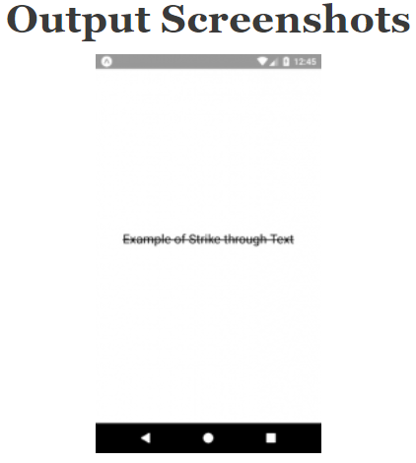

/*This is an example of React Native Strikethrough Text*/

import React, { Component } from 'react';

import { StyleSheet, View, Text } from 'react-native';

export default class App extends Component {

render() {

return (

<View style={styles.MainContainer}>

<Text style={styles.TextStyle}>

Example of Strike through Text

</Text>

</View>

);

}

}

const styles = StyleSheet.create({

MainContainer: {

justifyContent: 'center',

flex: 1,

margin: 10,

},

TextStyle: {

textAlign: 'center',

fontSize: 20,

textDecorationLine: 'line-through', // Strikethrough

textDecorationLine: 'underline', //Underline

//line-through is the trick

},

});